**cat /proc/info**

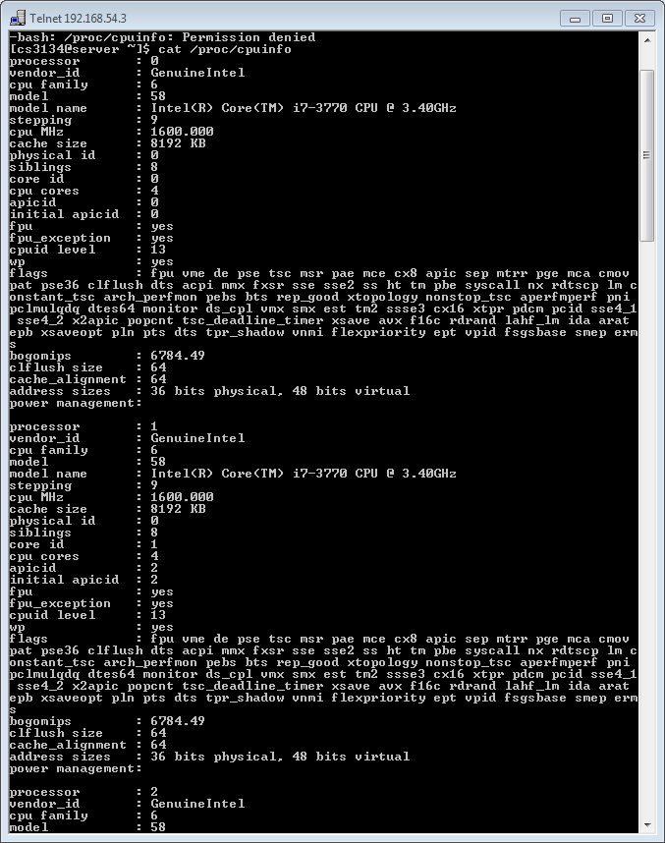

**Cat /proc/sys/kernel/osrelease**

**Cat /proc/cpu/uptime** :

first no – total no of sec for which system has been up/on

Second no – how much of the time machine has spend idle in seconds

**Cat /proc/stat :** shows diff stats of the system since last restarted (cpu0 to cpu7 ---> core i7 available)

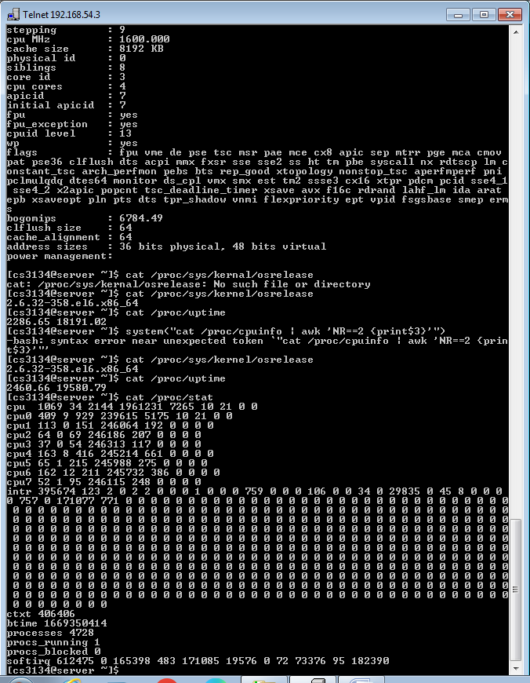

**The very first line CPU aggregates the number in all other CPU lines**

**Cat /proc/meminfo**

**~ Print these two details**

* **Amount of memory configured**
* **Amount of memory currently available**

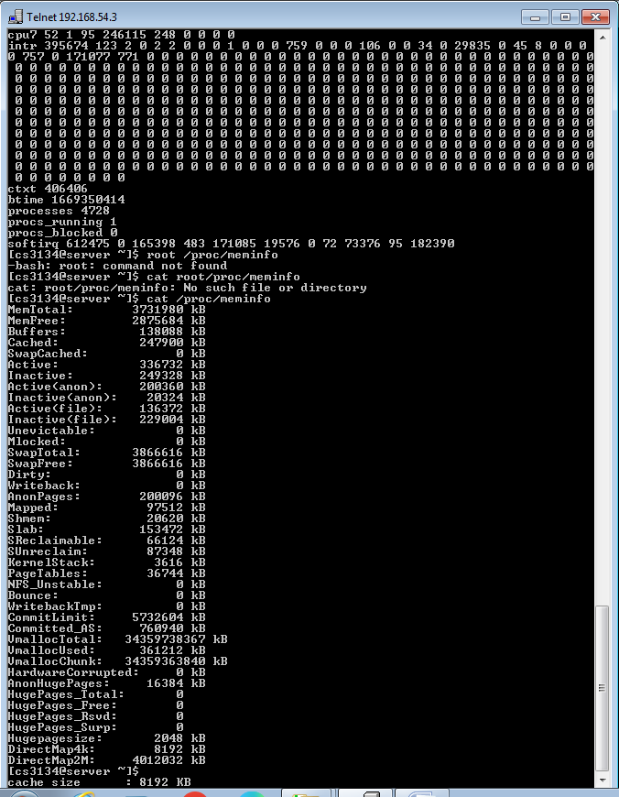

**Shows average CPU utilization in last 1min, 5 min wtf**

**Currently running processes and total number of processes**

**Last column – process ID of last process used/run**

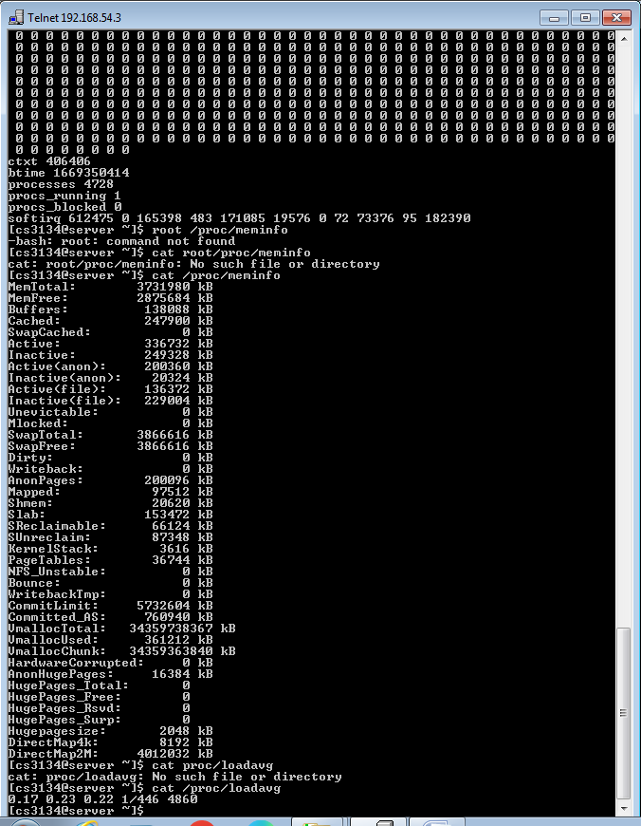

**PRACTICAL QUESTION 2 ::**

